Master Gardener Association Genesee County MI
Matthaei Botanical Gardens Bus Trip
Friday, July 19, 2024
Leave Flint ay 8 AM Arrive back in Flint 3 PM
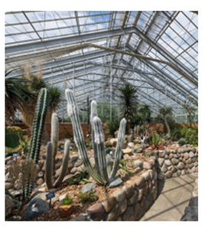
Conservatory ​ 1 hour Guided Tour
- Tropical House – Plants from warm, frost-free climates.
- Temperate House – Plants from cold winter and hot summer climates.
- Arid House - Plump, short, spiny, and weird all describe plants in the arid house.
$45 Early Registration (deadline June 19)
$50 late registration
Mail a check and registration to
MGAGCM
PO Box 94
Flushing, MI 48433
Name ____________________________________
# people __________________________________
Phone ___________________________________
Email ____________________________________
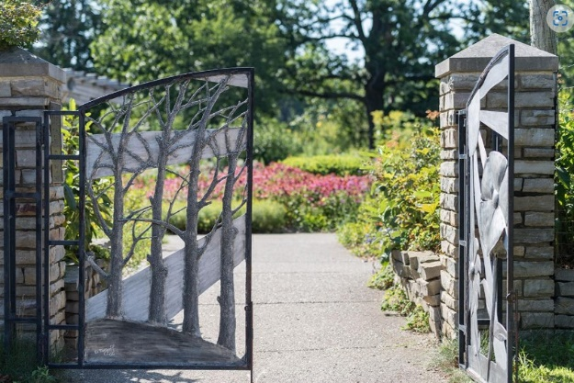
Gateway Garden
Three Mile Stroll through 9 gardens with places to sit and relax.
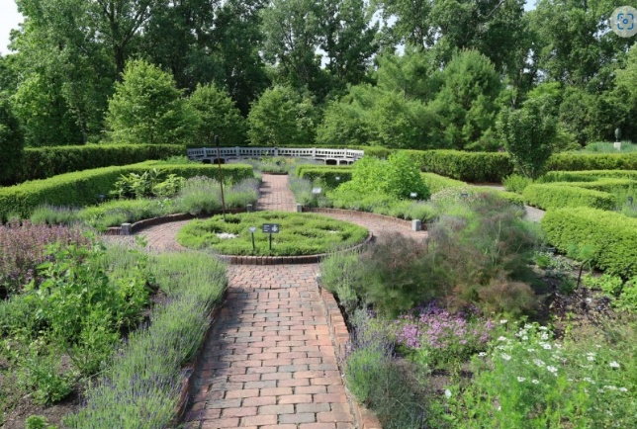
Alexandra Hicks Herb Knot Garden
Price includes
• 1 hr. Conservatory guided tour
• Snacks & water
• You will need to pack a lunch
- Gaffield Children's Garden
Questions – call Kay 810-610-0545
Visit Https://www.GeneseeCountyMG.org
For more information or to register online

Emergency Contact _________________________

Number _______________________________

