<Master Gardener Association Genesee County Michigan
(MGAGCM)

2020 Native Plant Sale Order Form

Name:

Address:

City, State, Zip: County:

Phone: Email (required for confirmation):

Quantity Price Total
Grasses: x $6.00 $
Wildflowers: x $6.00 $
Garden Kits: x $120.00 $
Total Cost $
Payment:
Check
Payable to: <MGAGCM>

Credit Card (please circle one)
Visa Master Card Discover American Express
Name on card:

Card Number: Expiration:

Cardholder signature:

Mail completed forms with payment to: For more information, contact:

<MGAGCM Dick Moldenhauer
P.O> Box 981 Email: RNMOLD1050@aol.com
Grand Blanc, MI 48480>

* Pre-sale order forms must be submitted to MGAGCM by <May 2, 2020 at 5 P.M.>. All orders must be picked up <May 16, 2020> between <9 AM and 2 PM> at <Davison Farmer’s Market>.

<geneseecountymg.org>

Common Name | Sun | Water | Scientific Name | Quantity
Grasses: (per quart) |  |  |  | $6.00
Big Bluestem |  |  | Andropogon gerardii
Bottlebrush Grass |  | 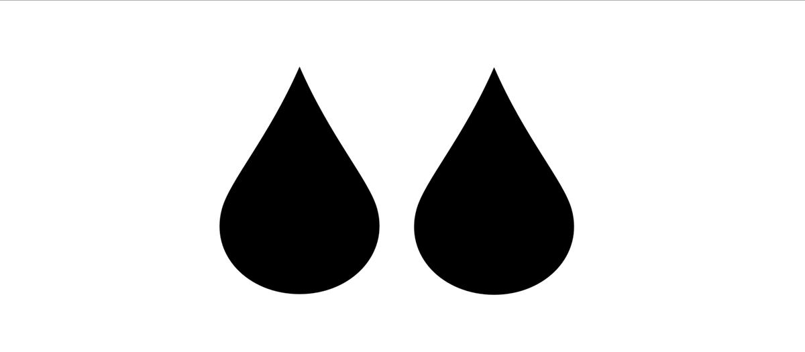 | Hystrix patula
Brown Fox Sedge |  |  | Carex vulpinoidea
Indian Grass |  |  | Sorghastrum nutans
June Grass |  |  | Koeleria cristata
Little Bluestem |  |  | Schizachyrium scoparium
Prairie Dropseed |  |  | Sporobolus heterolepsis
Side Oats Grama |  |  | Bouteloua curtipendula
Switch Grass |  |  | Panicum virgatum
Wildflowers: (per quart) |  |  |  | $6.00
Alleghany Monkey Flower |  |  | Mimulus ringens
Black-Eyed Susan |  |  | Rudbeckia hirta
Blue-Stemmed Goldenrod |  |  | Solidago caesia
Blue Vervain |  |  | Verbena hastata
Boneset |  |  | Eupatorium perfoliatum
Bottle Gentian |  |  | Gentiana andrewsii
Butterfly Weed |  |  | Asclepias tuberosa
Cardinal Flower |  |  | Lobelia cardinalis
Compass Plant |  |  | Silphium laciniatum
Cream Wild Indigo |  |  | Baptisia bracteata
Culver's Root |  |  | Veronicastrum virginicum
Cup Plant |  |  | Silphium perfoliatum
Downy Sunflower |  |  | Helianthus mollis
Early Sunflower |  |  | Heliopsis helianthoides
False Boneset |  |  | Khunia eupatorioides
False Dragonhead (Obedient plant) |  |  | Phytostegia virginiana
False Nettle* |  |  | Boehmeria cylindrica
Fireweed |  |  | Chamaenerion angustifolium
Foxglove Beard Tongue (Smooth Penstemon) |  |  | Penstemon digitalis
Giant Sunflower |  |  | Helianthus giganteus
Golden Alexanders |  |  | Zizia aurea
Gray Headed Coneflower |  |  | Ratibida pinnata
Golden Alexanders |  |  | Zizia aurea
Great Blue Lobelia |  |  | Lobelia siphilitica
Hairy Beard Tongue |  |  | Penstomon hirsutus
Harebell |  |  | Campanula rotundifolia
Hibiscus/Rose Mallow |  |  | Hibiscus laevis
Hoary Vervain |  |  | Verbena stricta
Horsemint |  |  | Monarda punctata
Ironweed |  |  | Vernonia missurica
Joe Pye Weed |  |  | Eutrochium maculatum
Leadplant |  |  | Amorpha canescens
Leafy Prairie Clover |  |  | Dalea foliosa
Common Name | Sun | Water | Scientific Name | Quantity
Wildflowers continued: (per quart) |  |  |  | $6.00
Marsh Blazing Star |  |  | Liatris spicata
Maximillian Sunflower |  |  | Helianthus maximiliani
Mountain Mint |  |  | Pycnanthemum verticillatum
New England Aster |  |  | Aster novae-angliae
New Jersey Tea |  |  | Ceanothus americanus
Nodding Wild Onion |  |  | Allium cernuum
Northern Blazing Star |  |  | Liatris scariosa
Northern Blue Flag |  |  | Iris versicolor
Pale Indian Plantain |  |  | Arnoglossum atriplicifolium
Pale Purple Coneflower |  |  | Echinacea pallida
Pearly Everlasting* |  |  | Anaphalis margaritacea
Prairie Alumroot |  |  | Heuchera richardsonii
Prairie Blazing Star |  |  | Liatris pycnostachya
Prairie Coreopsis |  |  | Coreopsis palmata
Prairie Dock |  |  | Silphium terebinthinacoum
Prickly Pear |  |  | Opuntia humifusa
Purple Coneflower |  |  | Echinacea purpurea
Rattlesnake Master |  |  | Eryngium yuccifolium
Riddell's Goldenrod |  |  | Solidago riddellii
Rosinweed |  |  | Silphium integrifolium
Roundleaf Ragwort |  |  | Packera obovata
Sand Tickseed (Lanceleaf Coreopsis) |  |  | Coreopsis lanceolata
Showy Coneflower |  |  | Rudbeckia fulgida
Showy Goldenrod |  |  | Solidago speciosa
Shrubby Cinquefoil |  |  | Potentilla fruticosa
Sky Blue Aster |  |  | Symphyotrichum oolentangiense
Smooth Blue Aster |  |  | Symphyotrichum laeve
Sneezeweed |  |  | Helenium autumnale
Spiderwort |  |  | Tradescantia ohiensis
Spikenard |  |  | Aralia racemosa
Stiff Goldenrod |  |  | Solidago rigida
Swamp Milkweed (Red Milkweed) |  |  | Asclepias incarnata
Sweet Black-eyed Susan |  |  | Rudbeckia subtomentosa
Tall Bellflower |  |  | Campanula americana
Virgin's Bower |  |  | Clematis virginiana
Western Sunflower |  |  | Helianthus occidentalis
Wild Bergemot |  |  | Monarda fistulosa
Wild Blue Indigo |  |  | Baptisia australis
Wild Columbine |  |  | Aquilegia canadensis
Wild Petunia |  |  | Ruellia humills
Wild Senna |  |  | Senna marilandica
Woodland Sunflower |  |  | Helianthus divaricatus
Yellow Indigo |  |  | Baptisia tinctoria
Garden Kits: (38 plants per tray, 2" PLUG, design plan included) |  |  |  | $120.00
Butterfly
Pollinator
Wildflower
Shade
Rain Garden

Legend
Full Sun
Full Sun to Part Shade
Part Shade to Shade
Dry
Medium
Wet

*indicates NOT a Michigan genotype.

All plants are grown by Designs By Nature East, LLC, in Durand, Michigan, and are Michigan local genotypes, unless otherwise noted. All plants are grown without the use of pesticides.

Designs By Nature East, LLC, reserves the right to substitute plants or provide rain checks based on seasonal availability.

